Freezing delay test results

|  |  |  |  |
| --- | --- | --- | --- |
| SR.NO | Percentage of PAFP | Freezing time for stage 1 | Freezing time for stage 2 |
| 1 | 0% | 10 min | 16 min |
| 2 | 3% | 260 min | 290 min |
| 3 | 6% | 349 min | 379 min |
| 4 | 9% | 409 min | 459 min |

stage 1: soft surface, a pin can be inserted

Stage 2: hard surface, a pin cannot be inserted

At initial stage (0 min)

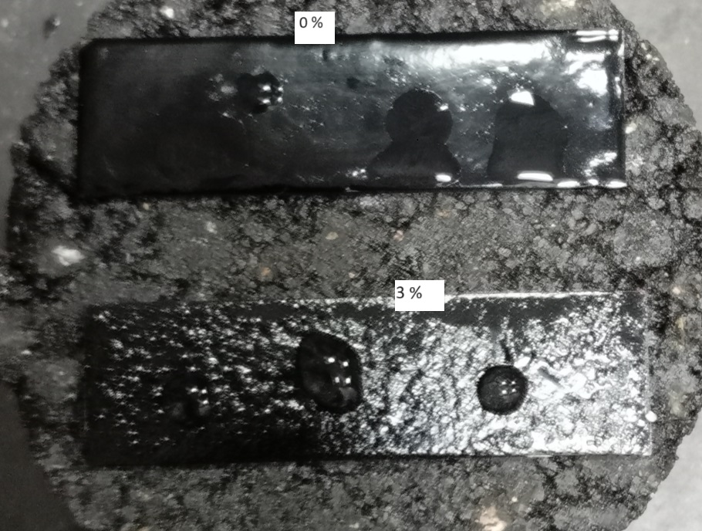

After 10 min (0 percent’s sample reached 1st stage

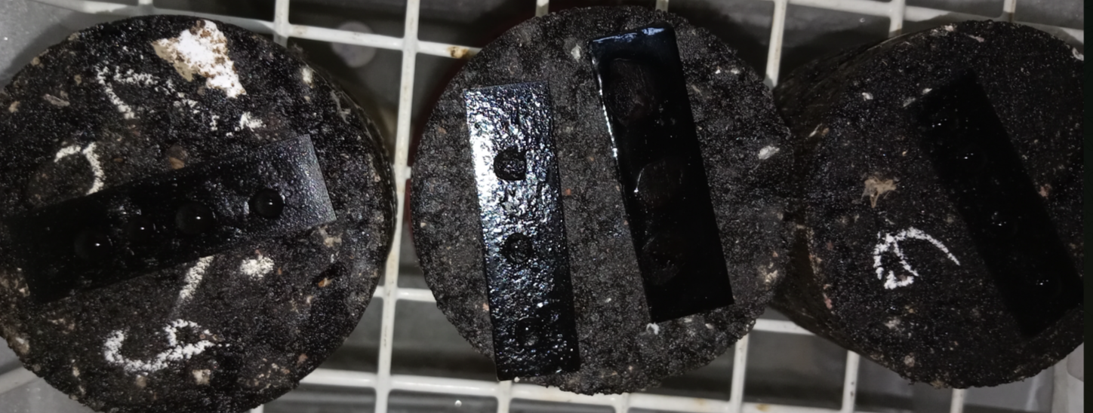



After 16 min ( 0 percent’s sample reached at 2nd stage

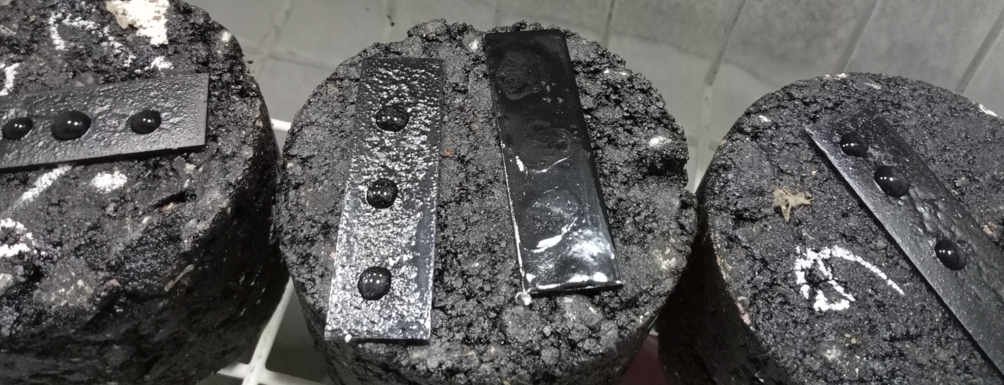



After 260 min ( 3 percent’s sample reached 1st stage

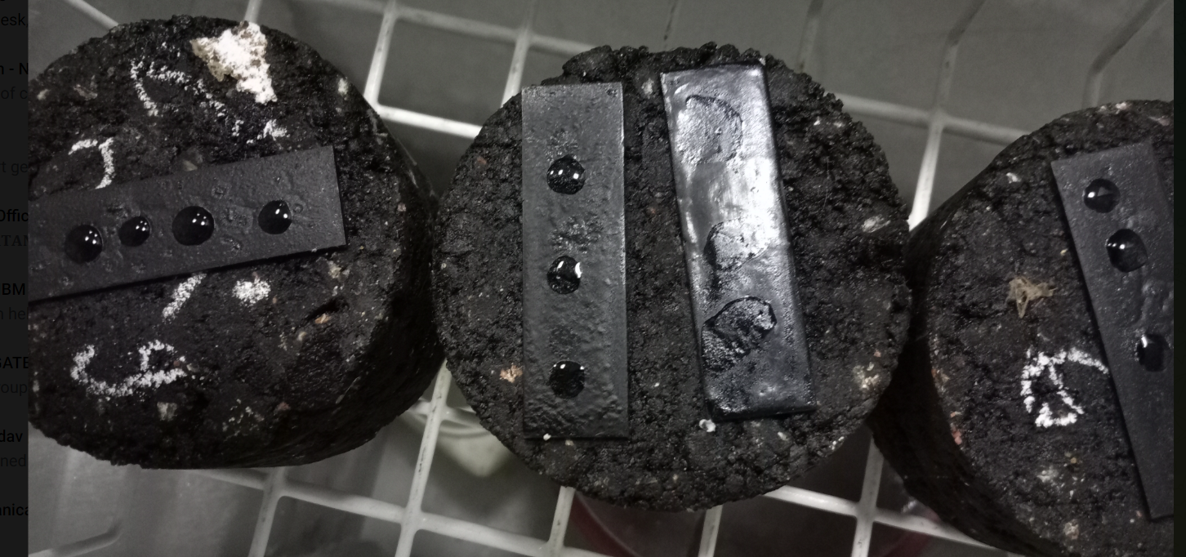



After 290 min ( 3 percent’s reached 2nd stage

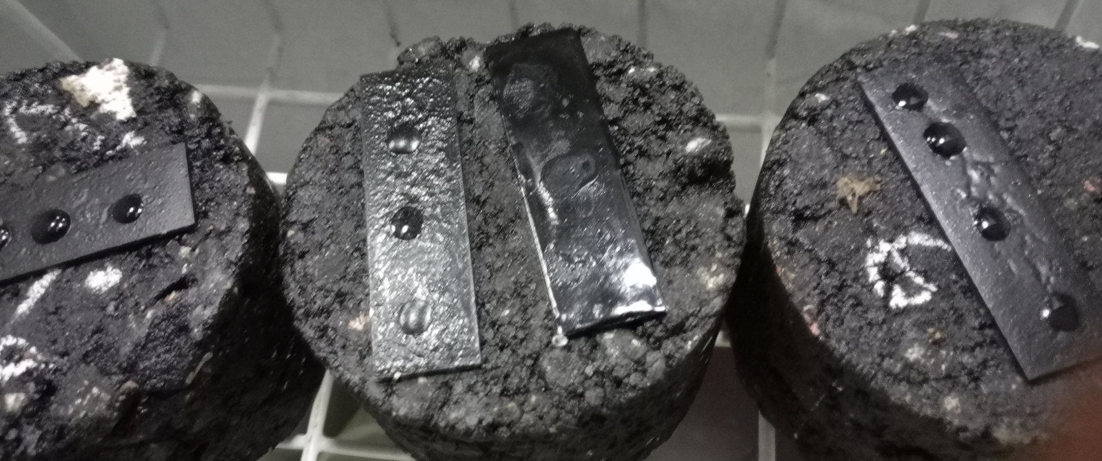



After 349 min (6 percent’s sample reached 1st stage

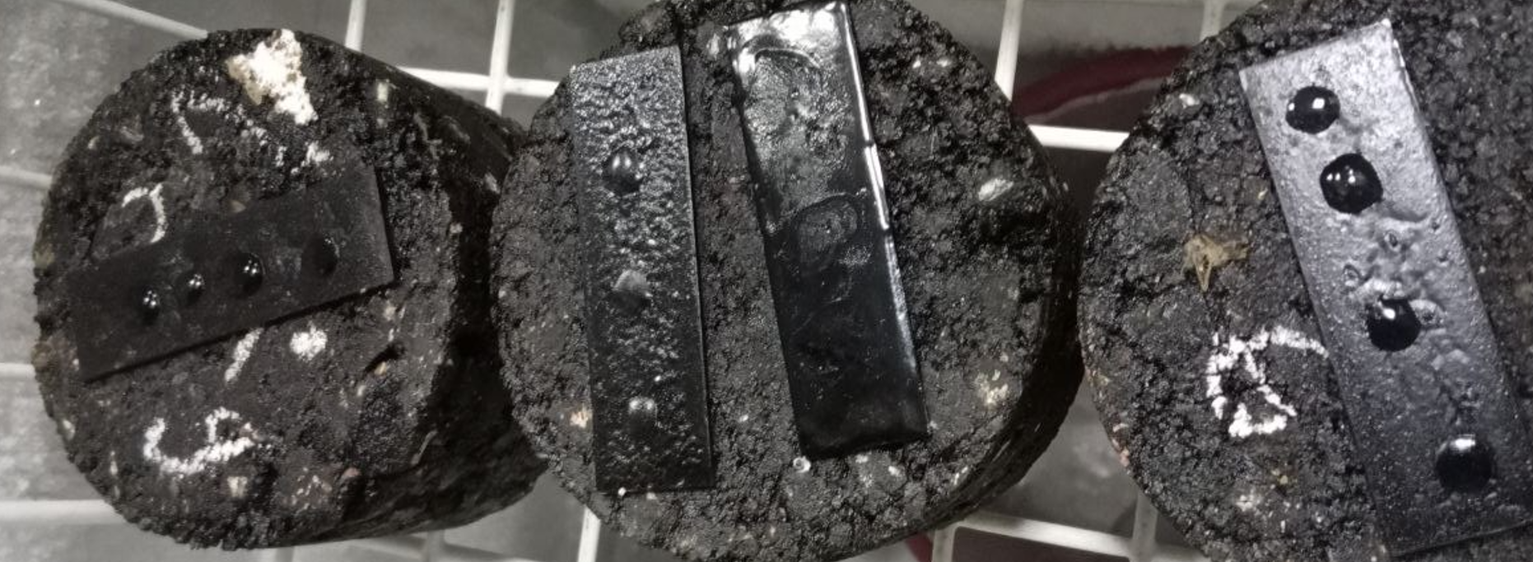



After 379 min( 6 percent’s sample reached 2nd stage

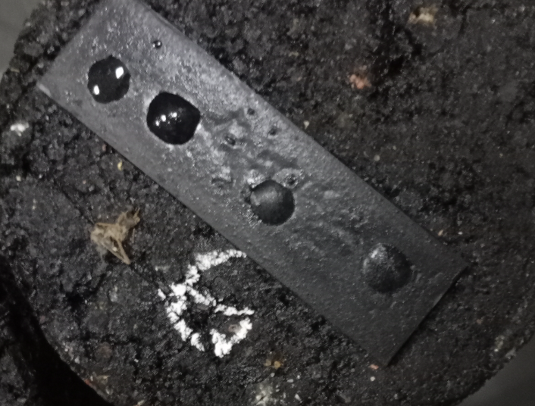



After 409 min (9 percent’s sample reached 1st stage 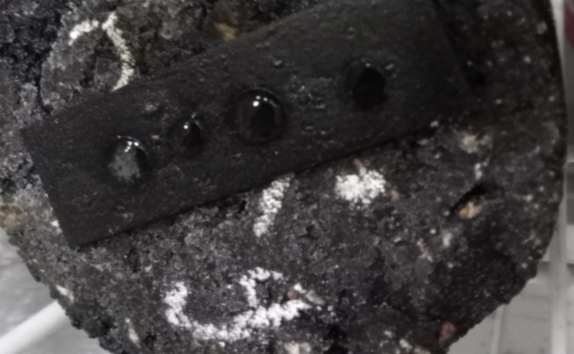



After 459 min (9 percent’s sample reached 2nd stage

